

PRESS RELEASE Prague 29 November 2018

Eduard Forejt joins PASSERINVEST GROUP

Eduard Forejt (41) holds the new position of Business Development Director in the development and investment company PASSERINVEST GROUP. His more than twenty years of experience in areas of real estate will contribute to the development of new business activities, acquisitions and company strategies.

Before joining PASSERINVEST GROUP, Eduard Forejt worked for twelve years in the Czech branch of Jones Lang LaSalle in a number of positions, such as Senior Negotiator of the Office Leasing Department, Head of Office Agency and Business Developer Director. He obtained his prior experience in King Sturge Real Estate Agency and ČSOB. In the last year he was involved in his own private business in the area of commercial real estate.

E. Forejt has been awarded the title CRE® (Counselor of Real Estate) from the prestigious American organisation The Counselors of Real Estate®. He lectures at the Czech Technical University in Prague in the Faculty of Architecture, regularly publishes professional articles and actively participates in important business conferences.

He divides his free time between his family and his hobbies, such as shooting, music and Harley-Davidson motorcycles.

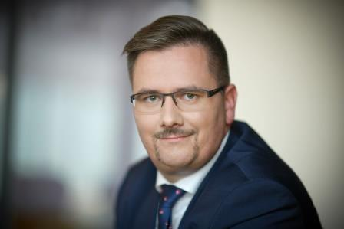

Eduard Forejt, Business Development Director of Passerinvest Group

You can get more information and photographs in print quality from:
Kristýna Samková, Head of PR and Marketing dept.
PASSERINVEST GROUP, a.s.
Tel.: (+420) 221 582 111
E-mail: Kristyna.Samkova@Passerinvest.cz
www.passerinvest.cz, www.bbcentrum.cz

Marcela Štefcová
Crest Communications a.s.
Mobil: (+420) 731 613 669
E-mail: marcela.stefcova@crestcom.cz
www.crestcom.cz

About the company

PASSERINVEST GROUP, a. s., is a purely Czech development and investment company, whose name is primarily connected with the realisation of the multifunctional BB Centrum complex in Prague 4 – Michle. The company, established by Radim Passer in 1991, built a very good reputation both on a local and international level with this, the most successful and extensive project of its kind in Central Europe. This is not only to the credit of the quality of the realised projects and the high level of the provided services, but also due to the sense of fair play, an accommodating relationship to the buildings’ tenants/users and responsibility to the society and the environment. PASSERINVEST GROUP also has other interesting development projects in its portfolio.

